Test Case: tc001_SPX_Dev5_Crear_Nueva_Linea_Requisicion_Spot_Tipo_Cobro_CC
Step 1 - Enter username and password and click to button Enter : Credentials Entered
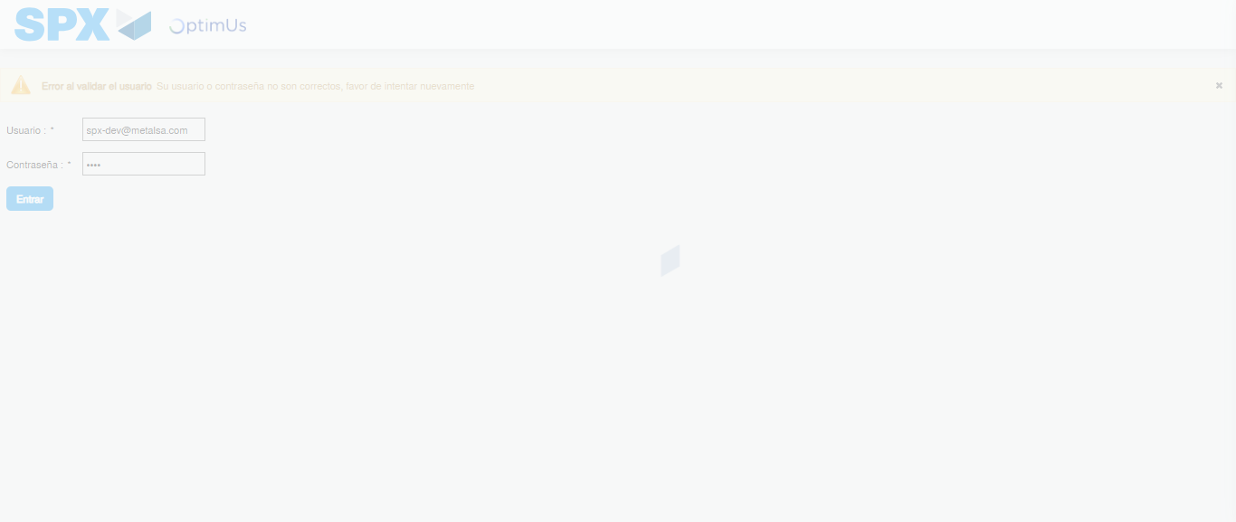Image file-name: QC_Testing-tc001_SPX_Dev5_Crear_Nueva_Linea_Requisicion_Spot_Tipo_Cobro_CC-1790175191222

Step 2 - Select to UEN and Access to Spot Buy Requisitions : UEN Correctly selected and Correct access
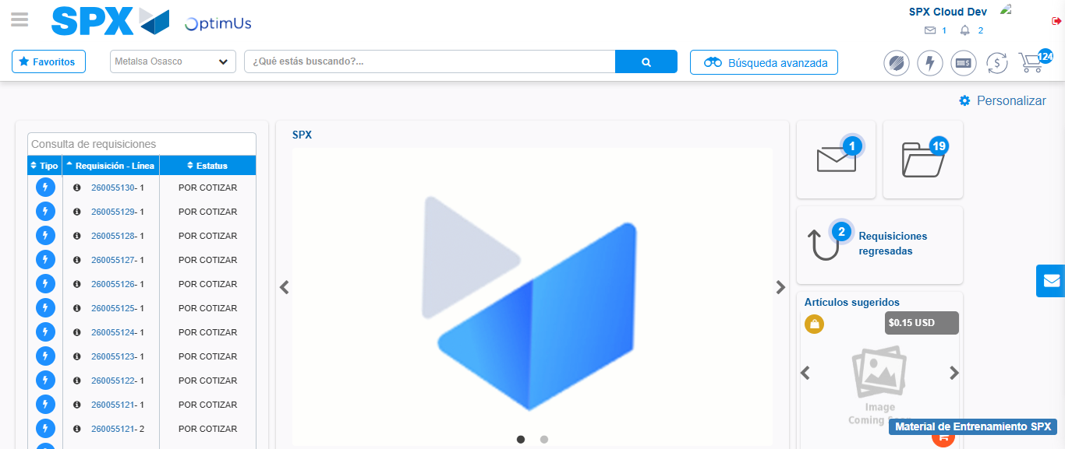Image file-name: QC_Testing-tc001_SPX_Dev5_Crear_Nueva_Linea_Requisicion_Spot_Tipo_Cobro_CC-1790175215040

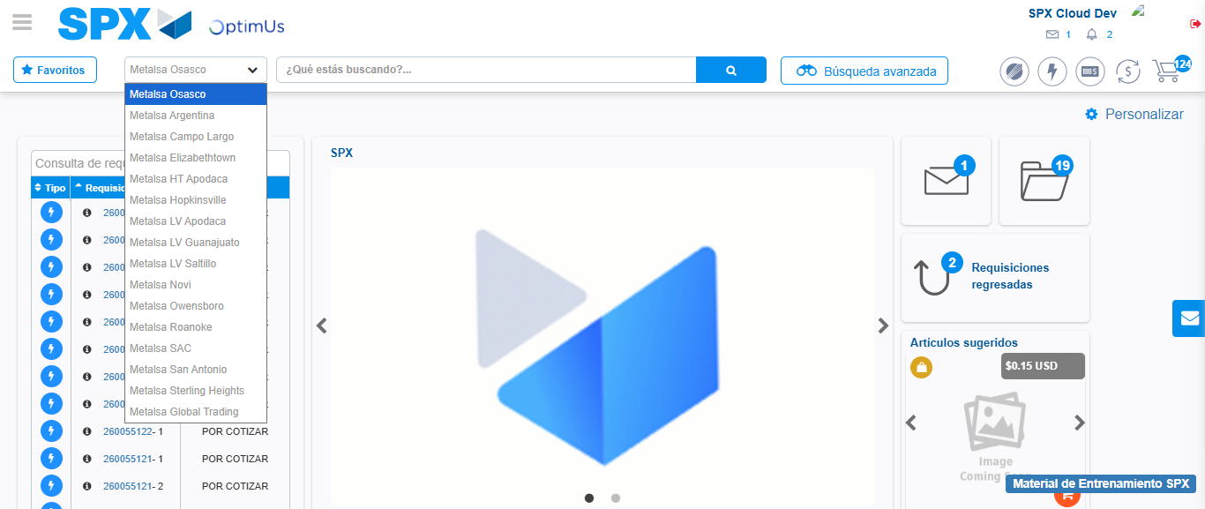Image file-name: QC_Testing-tc001_SPX_Dev5_Crear_Nueva_Linea_Requisicion_Spot_Tipo_Cobro_CC-1790175215649

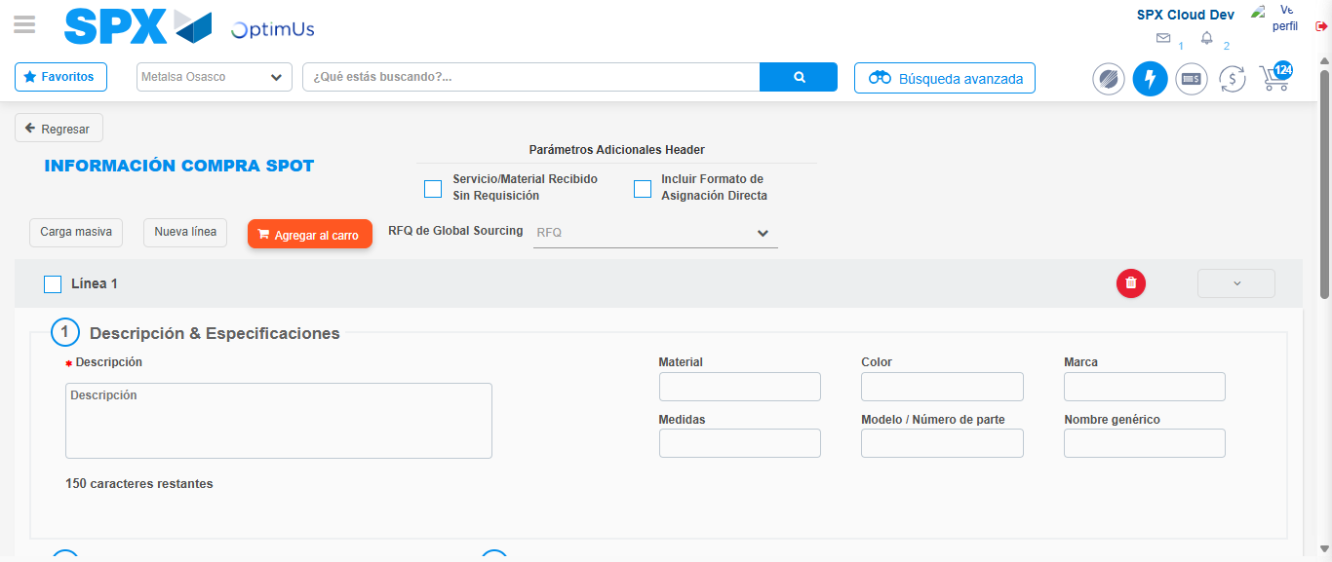Image file-name: QC_Testing-tc001_SPX_Dev5_Crear_Nueva_Linea_Requisicion_Spot_Tipo_Cobro_CC-1790175242036

Step 3 - Data Capture Spot Buy Requisition: Data captured correctly
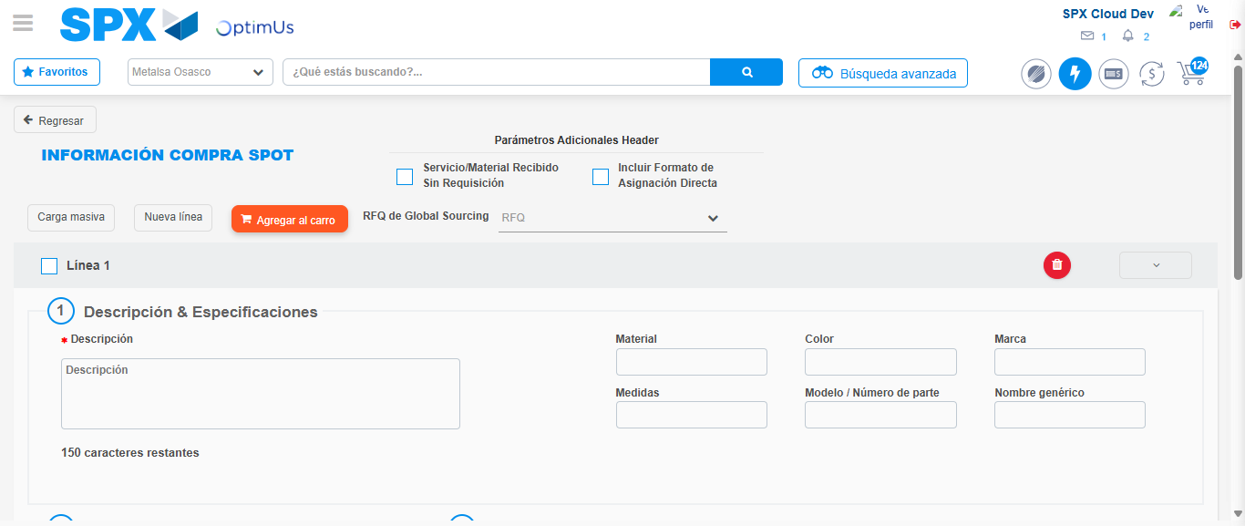Image file-name: QC_Testing-tc001_SPX_Dev5_Crear_Nueva_Linea_Requisicion_Spot_Tipo_Cobro_CC-1790175242339

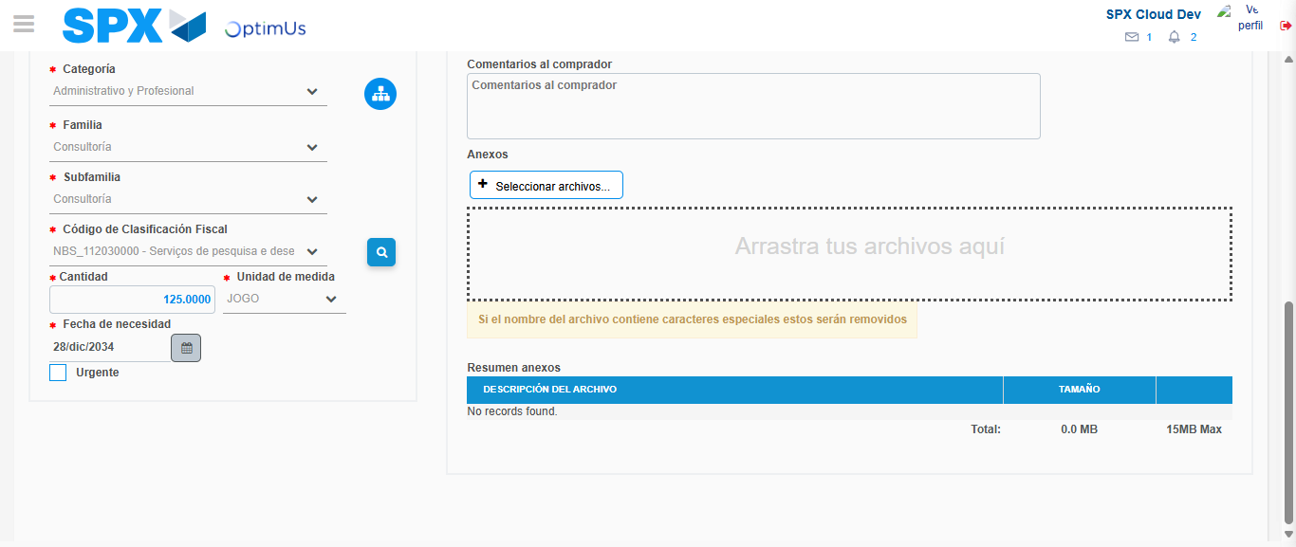Image file-name: QC_Testing-tc001_SPX_Dev5_Crear_Nueva_Linea_Requisicion_Spot_Tipo_Cobro_CC-1790175270963

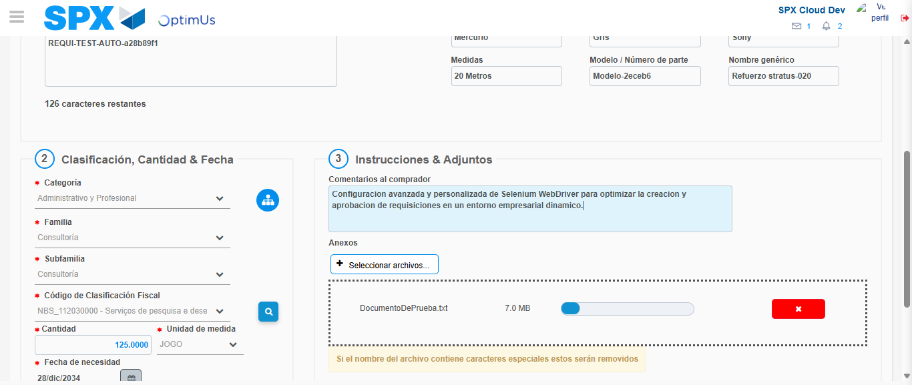Image file-name: QC_Testing-tc001_SPX_Dev5_Crear_Nueva_Linea_Requisicion_Spot_Tipo_Cobro_CC-1790175271814

Step 4 - Add new line and data capture second line: Line add correctly
Image file-name: QC_Testing-tc001_SPX_Dev5_Crear_Nueva_Linea_Requisicion_Spot_Tipo_Cobro_CC-1790175242339

Image file-name: QC_Testing-tc001_SPX_Dev5_Crear_Nueva_Linea_Requisicion_Spot_Tipo_Cobro_CC-1790175270963

Image file-name: QC_Testing-tc001_SPX_Dev5_Crear_Nueva_Linea_Requisicion_Spot_Tipo_Cobro_CC-1790175271814

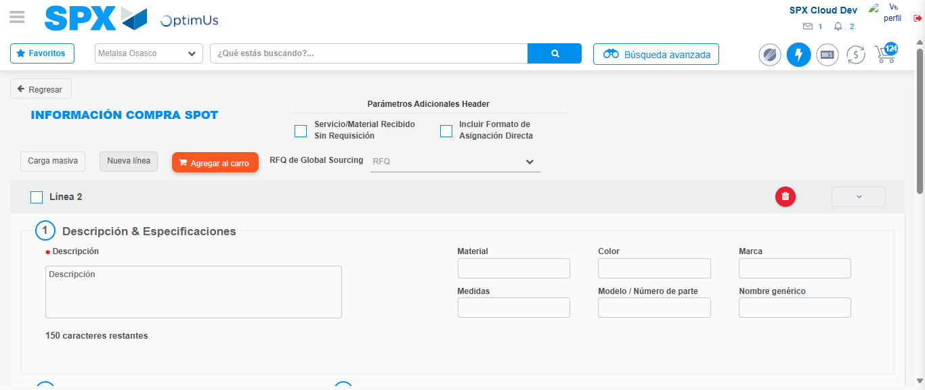Image file-name: QC_Testing-tc001_SPX_Dev5_Crear_Nueva_Linea_Requisicion_Spot_Tipo_Cobro_CC-1790175274155

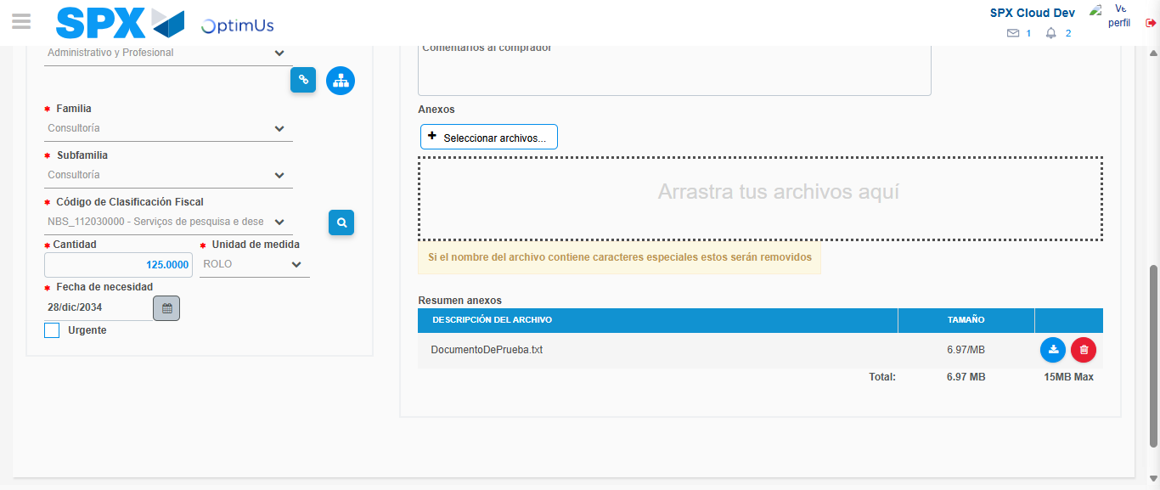Image file-name: QC_Testing-tc001_SPX_Dev5_Crear_Nueva_Linea_Requisicion_Spot_Tipo_Cobro_CC-1790175298998

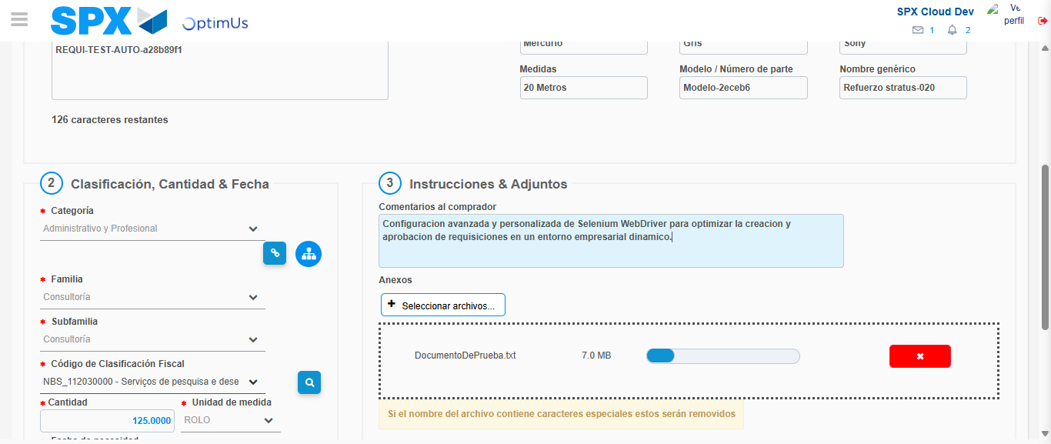Image file-name: QC_Testing-tc001_SPX_Dev5_Crear_Nueva_Linea_Requisicion_Spot_Tipo_Cobro_CC-1790175300084

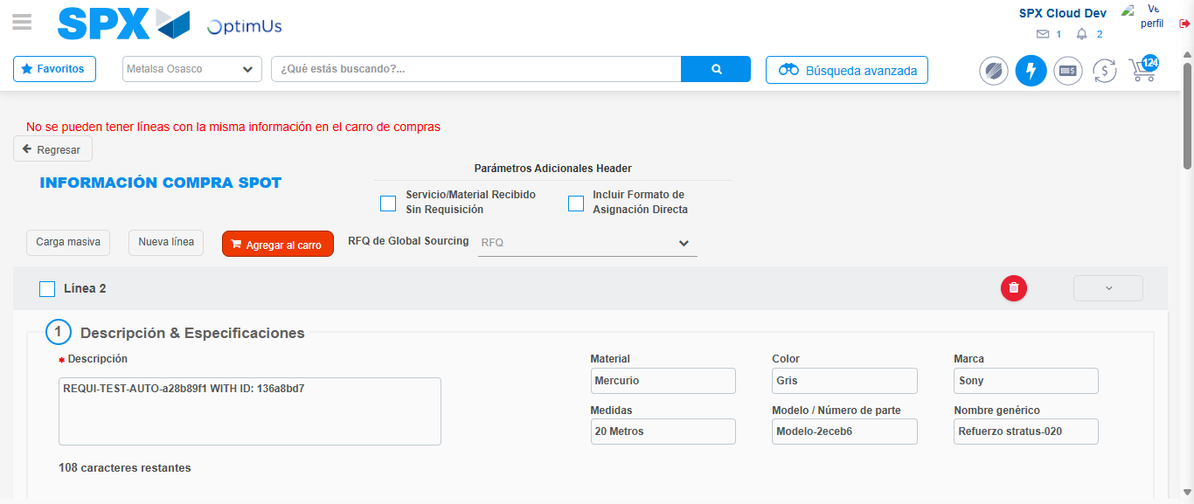Image file-name: QC_Testing-tc001_SPX_Dev5_Crear_Nueva_Linea_Requisicion_Spot_Tipo_Cobro_CC-1790175305062

Step 8 - Return to Main Page SPX : Return to Main Page SPX
Image file-name: QC_Testing-tc001_SPX_Dev5_Crear_Nueva_Linea_Requisicion_Spot_Tipo_Cobro_CC-1790175215040

Image file-name: QC_Testing-tc001_SPX_Dev5_Crear_Nueva_Linea_Requisicion_Spot_Tipo_Cobro_CC-1790175215649

Image file-name: QC_Testing-tc001_SPX_Dev5_Crear_Nueva_Linea_Requisicion_Spot_Tipo_Cobro_CC-1790175242036

Image file-name: QC_Testing-tc001_SPX_Dev5_Crear_Nueva_Linea_Requisicion_Spot_Tipo_Cobro_CC-1790175307364

Image file-name: QC_Testing-tc001_SPX_Dev5_Crear_Nueva_Linea_Requisicion_Spot_Tipo_Cobro_CC-1790175307566

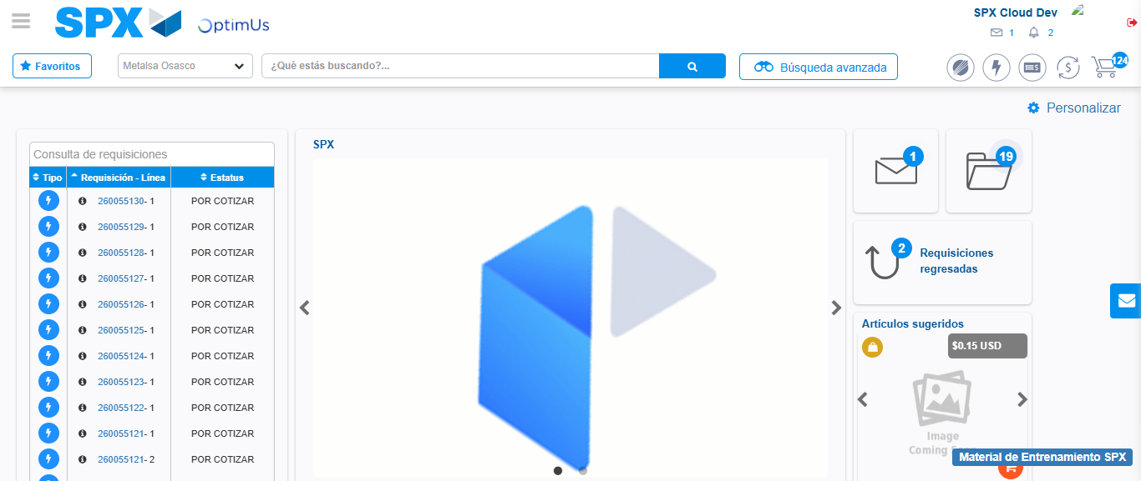Image file-name: QC_Testing-tc001_SPX_Dev5_Crear_Nueva_Linea_Requisicion_Spot_Tipo_Cobro_CC-1790175329019

Step 9 - Log Out : Log Out SPX
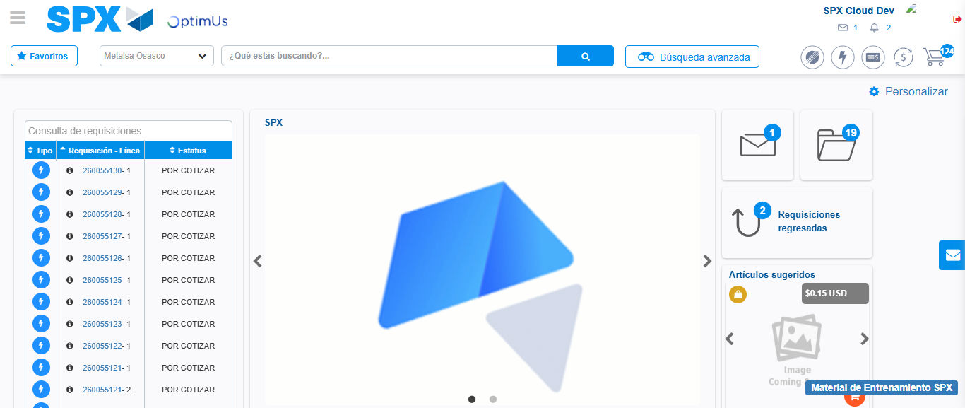Image file-name: QC_Testing-tc001_SPX_Dev5_Crear_Nueva_Linea_Requisicion_Spot_Tipo_Cobro_CC-1790175329387

